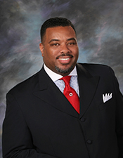
Sermon Notes

Date:
Preacher: Rev. Dr. Selwyn Q. Bachus

Scripture:

Sermon Subject:

Main Points:
I.

II.

III.

