Sermon Notes

JUNE 12, 2016
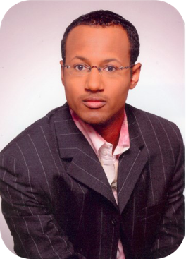
Guest: Rev. Stephen J. Thurston, II

Scripture:

Sermon Subject:

Main Points:
I.

II.

III.

